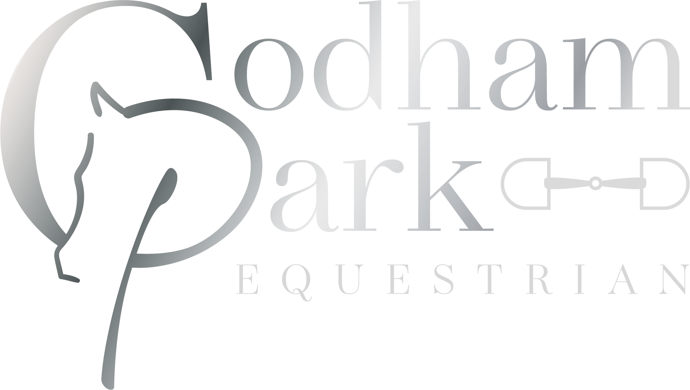


Codham Park CASH Unaffiliated Show Jumping

Sunday 4th October 2026

Always Check the Drawn Order Start List
All classes will run as single phase, we reserve the right to change class format & start times if necessary.

CLASS 1 30cm X-pole (Pony)
CLASS 1a 30cm X-Pole (Horse)

CLASS 2 50cm – 55cm Novice (Pony)
CLASS 2a 50cm – 55cm Novice (Horse)

CLASS 3 60cm 65cm Open (Pony)
CLASS 3a 60cm – 65cm Open (Horse)

CLASS 4 70cm – 75cm Open (Pony)
CLASS 4a 70cm – 75cm Open (Horse)

CLASS 5 80cm – 85cm Open (Pony)
CLASS 5a 80cm – 85cm Open (Horse)

CLASS 6 90cm – 95cm Open (Pony)
CLASS 6a 90cm – 95cm Open (Horse)

CLASS 7 1m-1.05m Open (Pony)
CLASS 7a 1m – 1.05m Open (Horse)

CLASS 8 1.05m – 1.10m Open (Pony)
CLASS 8a 1.05 – 110m Open (Horse)

Classes are split horses and ponies but are run together, and you may course walk after each height increase.

Please make sure you enter the correct section of your class for judging purposes.

ROSETTES 1ST - 6TH PLACE
Prize money will be awarded in accordance with one prize money amount for every 5 entries and so on down the line.
CASH PRIZES ALLOCATED AS FOLLOWS:-
1st - £25 (5 entries min)
2nd - £20 (10 entries min)
3rd - £15 (15 entries min)
4th - £10 (20 entries min)
5th - £5 (25 entries min)
6th - £5 (30 entries min)

Prize money is payable via your Equus account after the show is concluded.
ENTRIES VIA OUR WEBSITE ONLY:
CODHAM PARK MEMBERS £14.00 PER CLASS NON-MEMBER: £15.00 PER CLASS
First Aid / First Responder £5.00 PER RIDER

Codham Little Park Farm. Codham Park Drive, Beazley End, Braintree, Essex. CM7 5JQ

What3words ///sting.hoofs.perused

Jo 07880 728550 or Amanda 07944068714

Directions:
From Colchester: leave Colchester on the A120 towards Braintree turn right on the roundabout to join the A131 towards Halstead/Sudbury, next roundabout turn left onto the B1053 Broad Rd, turn right at second mini roundabout into Church Lane (by Braintree College) continue on until the road name changes into Church Street, go over bridge then turn left onto the Bovingdon Road, keep on this road till you come to a S bend (left & right corner) go downhill then turn left at industrial access sign into Codham Park Drive. N: 51° 55.832’‚
E: 0° 31.813’
From Halstead/Gosfield: Turn off A1017 Hedingham/Braintree Road at Oak tree in Gosfield (Nr Kings Head Pub) into Church Road, follow onto Park Hall Road, turn left at junction on entering Beazley End, drop down hill and turn right at industrial access sign into Codham Park Drive. N: 51° 55.832’‚ E: 0° 31.813’
From Chelmsford & M11: Please avoid the town centre by taking the A120 bypass towards Halstead/Sudbury A131, next roundabout turn left onto the B1053 Broad Rd, turn right at second mini roundabout into Church Lane (by Braintree College) continue on until the road name changes into Church Street, go over bridge then turn left onto the Bovingdon Road, keep on this road till you come to a S bend (left & right corner) go downhill then turn left at industrial access sign into Codham Park Drive. N: 51° 55.832’‚ E: 0° 31.813’
Please Note: We strongly recommend that you use the routes suggested as some roads & protected lanes may not be suitable for lorries or trailers.

Codham Little Park Farm. Codham Park Drive, Beazley End, Braintree, Essex. CM7 5JQ.

Codham Park Equestrian’s Terms and Conditions:
Please Refer To Our Website Home Page for New General Data Protection Regulations!
Codham Park Equestrian has taken all reasonable precautions to ensure the health and safety of everyone present. For these measures to be effective, all visitors must take all reasonable precautions to avoid & prevent accidents occurring visitors must obey the instructions of the centre whether instructions are written or verbal. Codham Park Equestrian shall not be liable for any claim in respect of damage, loss, injury or accident to any person, horse or property howsoever caused. It shall be deemed a condition of entry that each entrant has read and understood these terms and conditions and shall indemnify Codham Park Equestrian or any person acting on their behalf against any legal action arising from such an incident.

No Lunging in the arenas at any time, please ask for permission to do so on the open grass area. No misuse of training aids whatsoever
All dogs must be kept on leads and cleaned up after. No smoking in the arena areas. All children under the age of 16 years must always be supervised by a responsible adult. All rubbish/litter to be removed from site or placed in bins provided. Please do not muck out your lorry in the lorry park.
In the event of any rider travelling to a show on their own, details of an emergency contact should be left with the secretary in case of an accident.
Cars / Lorries are parked in car park at owners own risk
Please only pick up your droppings in the warm-up arena if safe to do so and placed in the bins provided.

Hard hats to current BS VG1, PAS 015 or SEI ASTM F1163 04a Onwards, SNELL E2001 AS/NZS 3838 2003 onwards must be worn & correctly secured whilst mounted.
No competitor / rider shall allow a stallion for which they are responsible as owner, lessee, authorised agent or rider to compete or be prepared to compete, in any competition without taking adequate precautions to ensure competitors, officials or other members of the public are not put at risk of injury, Stallions must display a ribbon in the tail and be lead from the bit at all times.

No refunds will be given once classes are entered.
Any person who fails to comply with these terms & conditions will be liable to forfeit their fees & expulsion from site.
Entries can be paid online or paid on the day, We No longer accept cheques as a form of payment, Codham Park Equestrian reserve the right to cancel, add to or amend any of the training day clear rounds as they see fit due to weather conditions etc.

Contribution of £5 per rider will be added for first aid / First Responder Codham Park Equestrian has taken all reasonable precautions to ensure the health and safety of everyone present. For these measures to be effective, all visitors must take all reasonable precautions to avoid & prevent accidents occurring visitors must obey the instructions of the center whether instructions are written or verbal. Codham Park Equestrian shall not be liable for any claim in respect of damage, loss, injury or accident to any person, horse or property howsoever caused. It shall be deemed a condition of entry that each entrant has read and understood these terms and conditions and shall indemnify Codham Park Equestrian or any person acting on their behalf against any legal action arising from such an incident. No Lunging in the arenas at any time, please ask for permission to do so on the open grass area. No misuse of training aids whatsoever All dogs must be kept on leads and cleaned up after. No smoking in the arena areas. All children under the age of 16 years must be supervised by a responsible adult at all times. All rubbish/litter to be removed from site or placed in bins provided. Please do not muck out your lorry in the lorry park. In the event of any rider travelling to a show on their own, details of an emergency contact should be left with the secretary in case of an accident. Cars / Lorries are parked in car park at owners own risk Please only pick up your droppings in the warm-up arena if safe to do so and placed in the bins provided. Judge’s decision is FINAL, conduct must not be offensive to any show official. Current standard body protector and soft peak skull hat / cap, we advise to be worn & correctly secured whilst mounted at all times. No competitor / rider shall allow a stallion for which they are responsible as owner, lessee, authorised agent or rider to compete or be prepared to compete, in any competition without taking adequate precautions to ensure competitors, officials or other members of the public are not put at risk of injury, Stallions must display a ribbon in the tail and be lead from the bit at all times. No refunds will be given once classes are entered. Any person who fails to comply with these terms & conditions will be liable to forfeit their fees & expulsion from site. Entries can be paid online or paid on the day. Codham Park Equestrian reserve the right to cancel, add to or amend any of the Competitions as they see fit due to weather conditions etc.

Please Note: it is your responsibility to notify us when entering if you Do Not Wish for any of your Images or Results to be shared.

